Project title: The Tragedy of Flight:A Comprehensive crash analysis

1.Introduction:

1.1 Overview

An airplane crash analysis is a detailed investigation into the causes of an aviation accident. The goal of an airplane crash analysis is to identify any factors that contributed to the accident, with the ultimate goal of improving safety and preventing future accidents. The process of conducting an airplane crash analysis typically involves the collection and analysis of a wide range of data, including information about the aircraft and its systems, the operators, and any other relevant factors. This data is typically collected from Kaggle. Once the data has been collected, it is analysed through tableau, to identify any potential causes of the accident. The results of an airplane crash analysis are typically published in a report, which may include recommendations for improving safety and preventing similar accidents in the future. These recommendations may be implemented by the relevant authorities or industry organizations.

1.2 Purpose

This project is used to analyse the aviation industry, human error is the major cause of accidents. About 38% of 329 major airline crashes, 74% of 1627 commuter/air taxi crashes, and 85% of 27935 general aviation crashes were related to pilot error.[3] The Swiss cheese model is an accident causation model which analyzes the accident more from the human factor aspect. In the modern aviation industry, it is also used to analyze a database of past accidents in order to prevent an accident from happening. Many models have been used not only for the accident investigation but also for educational purpose.

2.Problem Definition and Design Thinking

2.1 Empathy Map

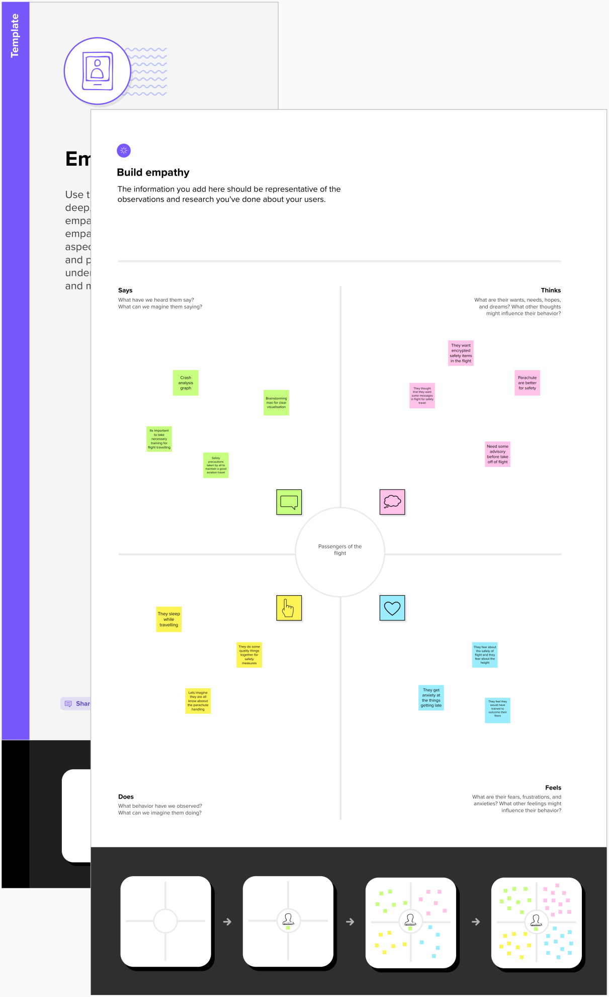 2.2 Ideation and Brainstorming map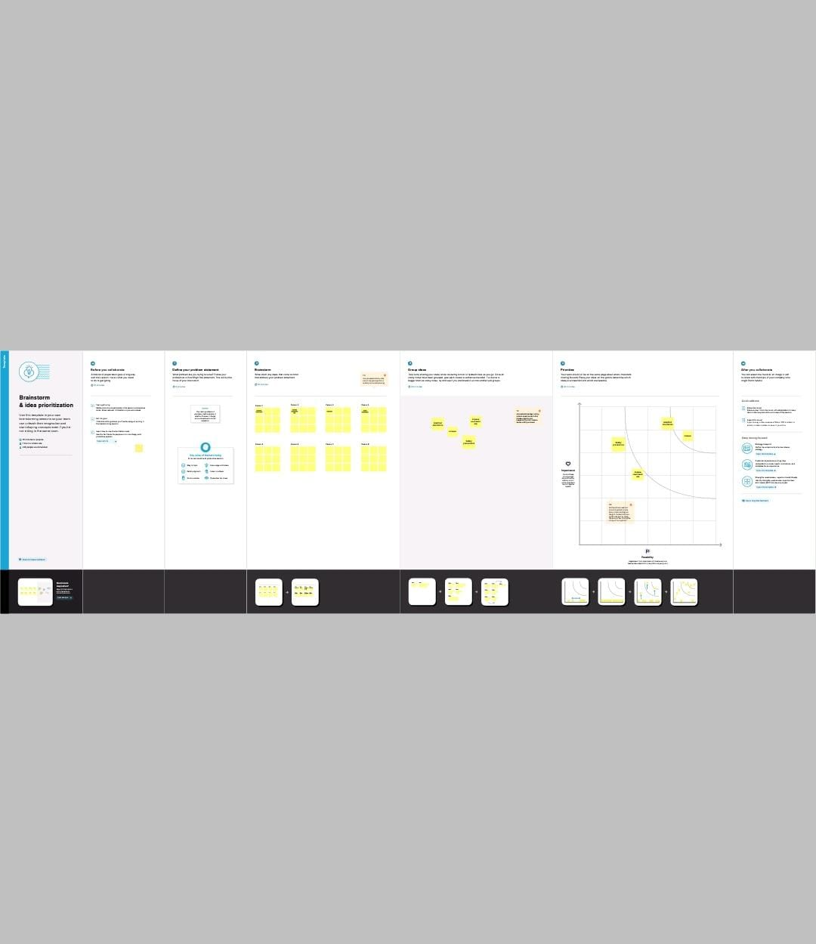

3.Result

To effectively discover the hazards that led to the accident and to prevent their recurrence in a future accident or incident. In the course of that investigation, additional hazards which increased damage and injury. Organizational influences: This layer is about resources management, organizational climate and organizational process. For example, a crew underestimating the cost of maintenance will leave the airplane and equipment in bad condition.This layer includes inadequate supervision, inappropriate operations, failure to correct a problem and supervisory violation. For example, if emergency procedure training is not provided to a new employee, it will increase the potential risk of a fatal accident.

The objective of accident analysis is to prevent accidents in the future. This statement is not as trivial as it looks: to many the objective is to identify those who were responsible, or simply to fulfill a legal or organisational requirement. When incidents are investigated, the emphasis should be concentrated on finding the root cause of the incident so you can prevent the event from happening again. The purpose is to find facts that can lead to corrective actions, not to find fault.

Outputs:

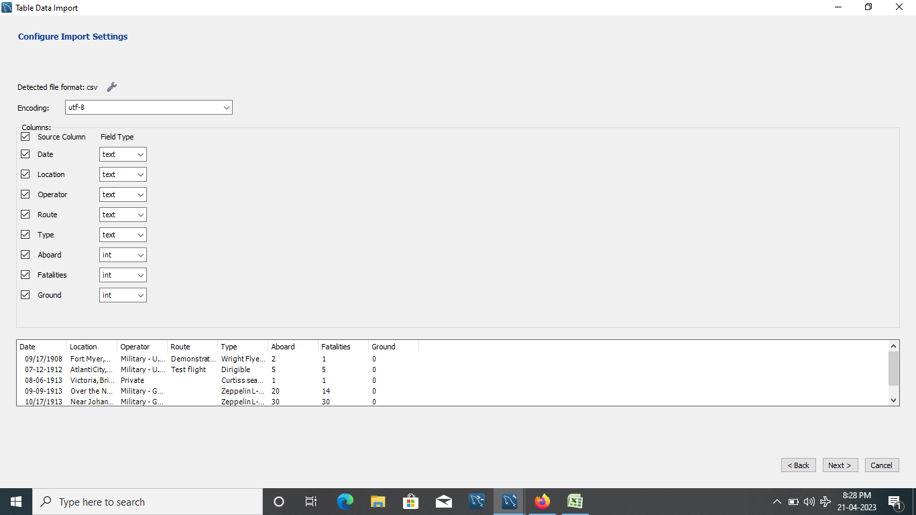

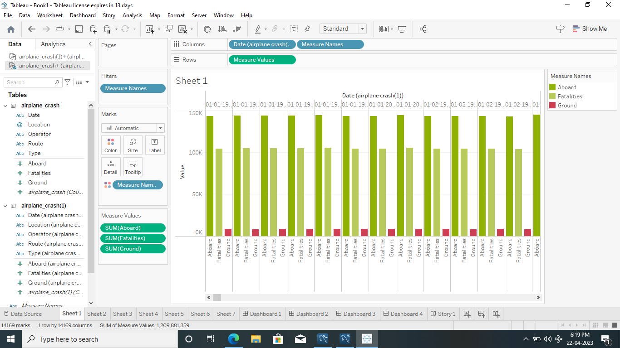

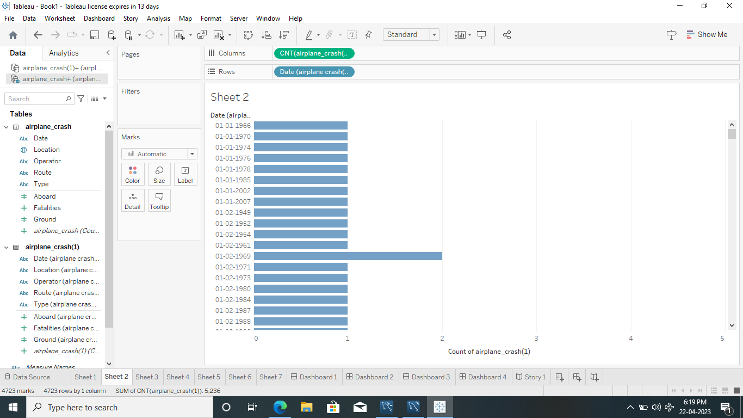

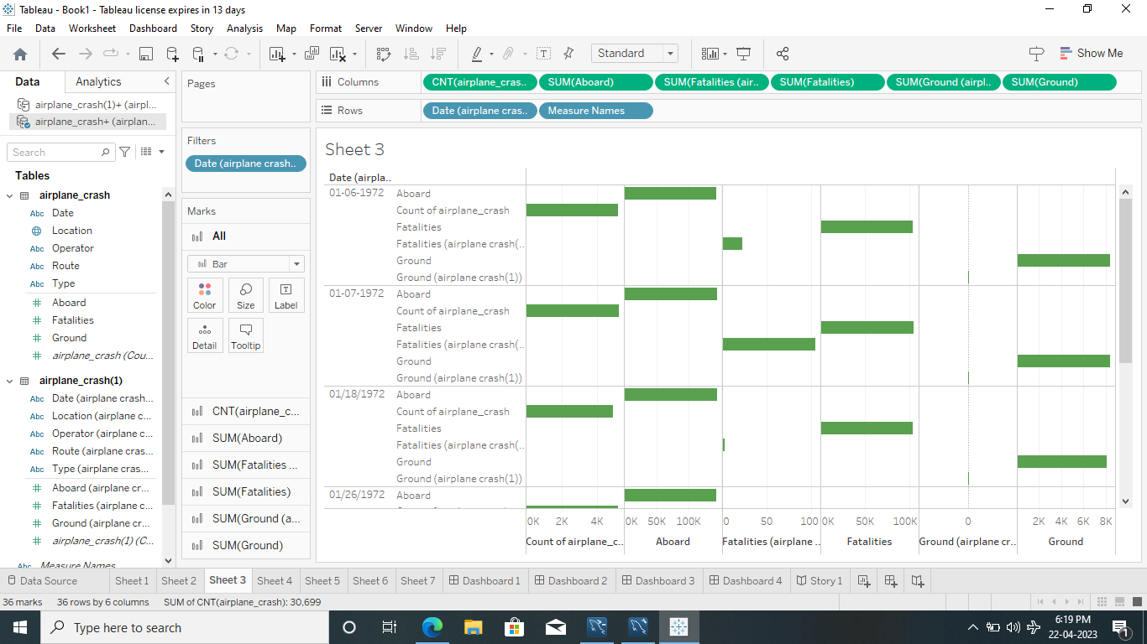

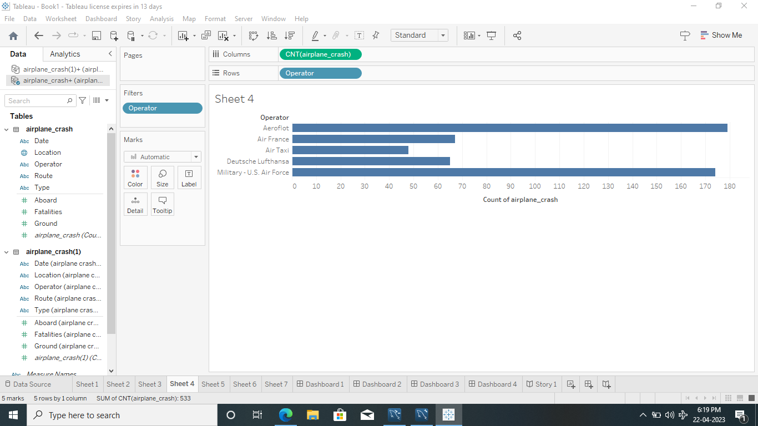

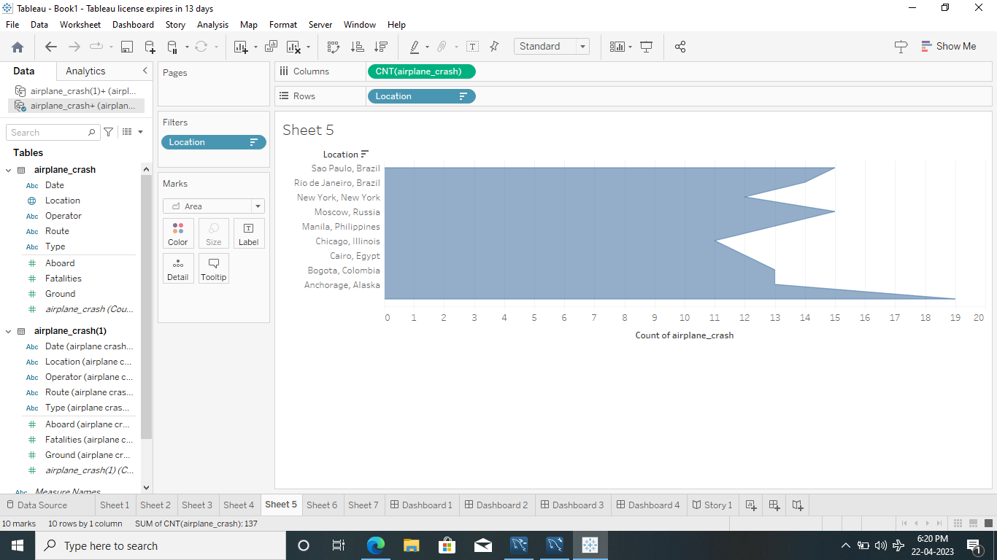

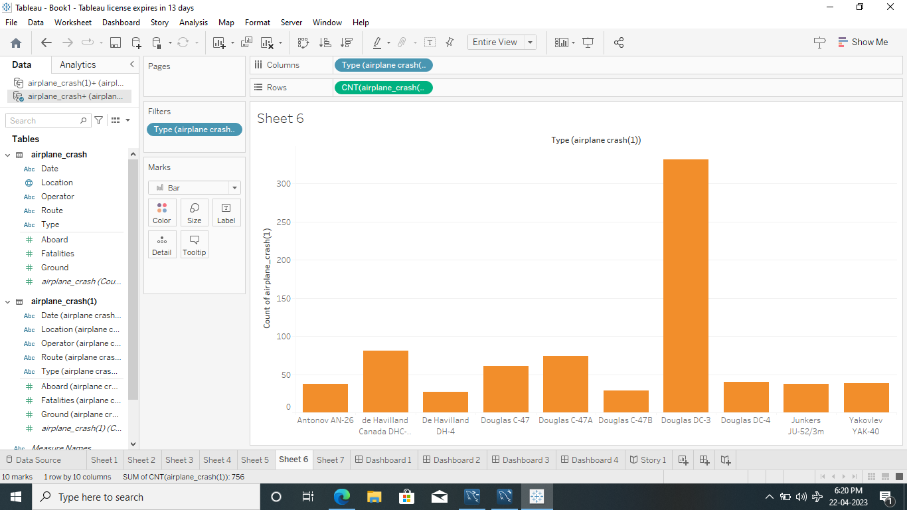

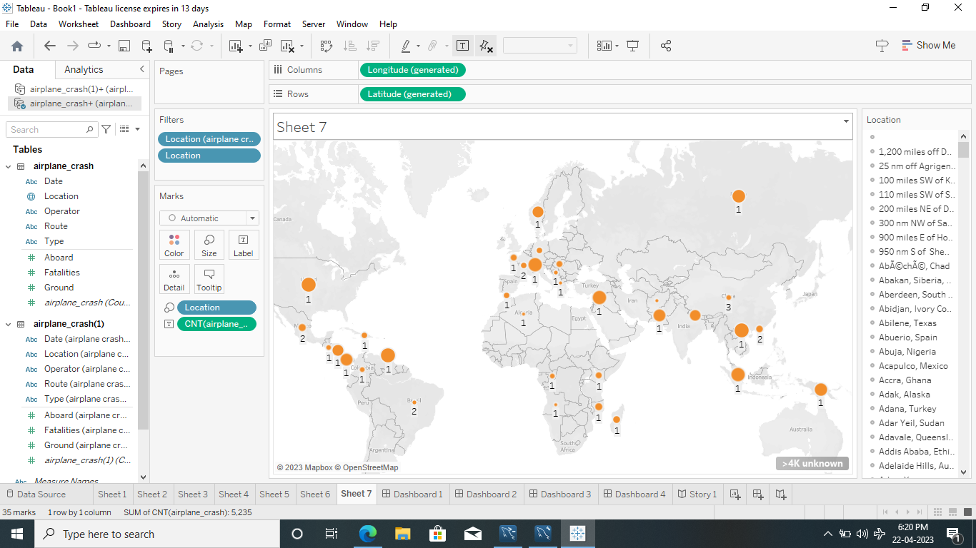

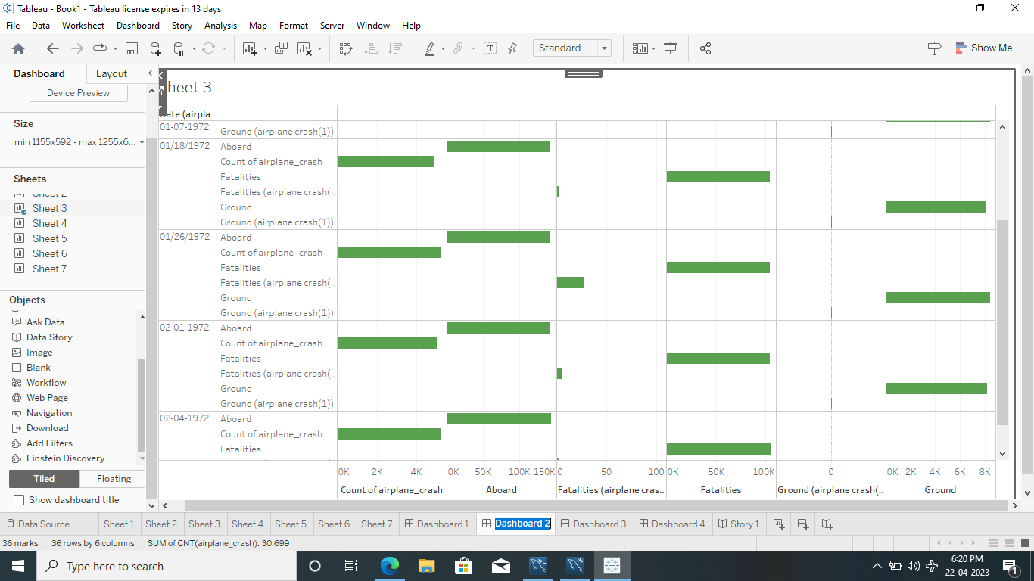

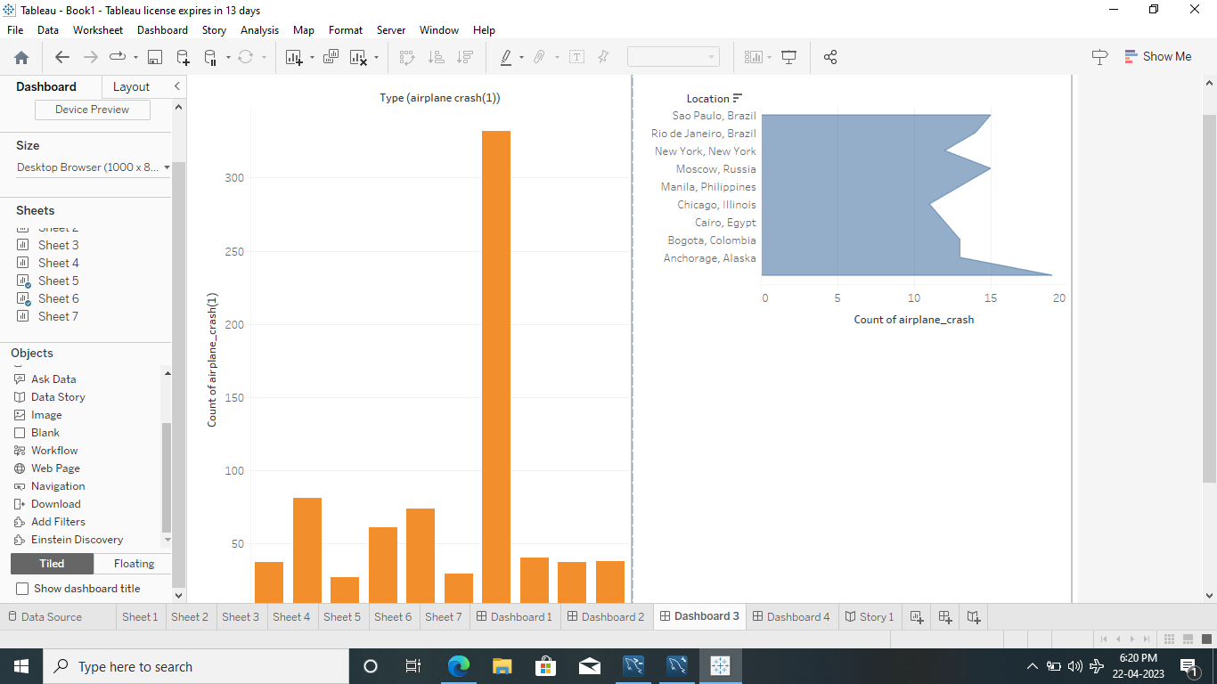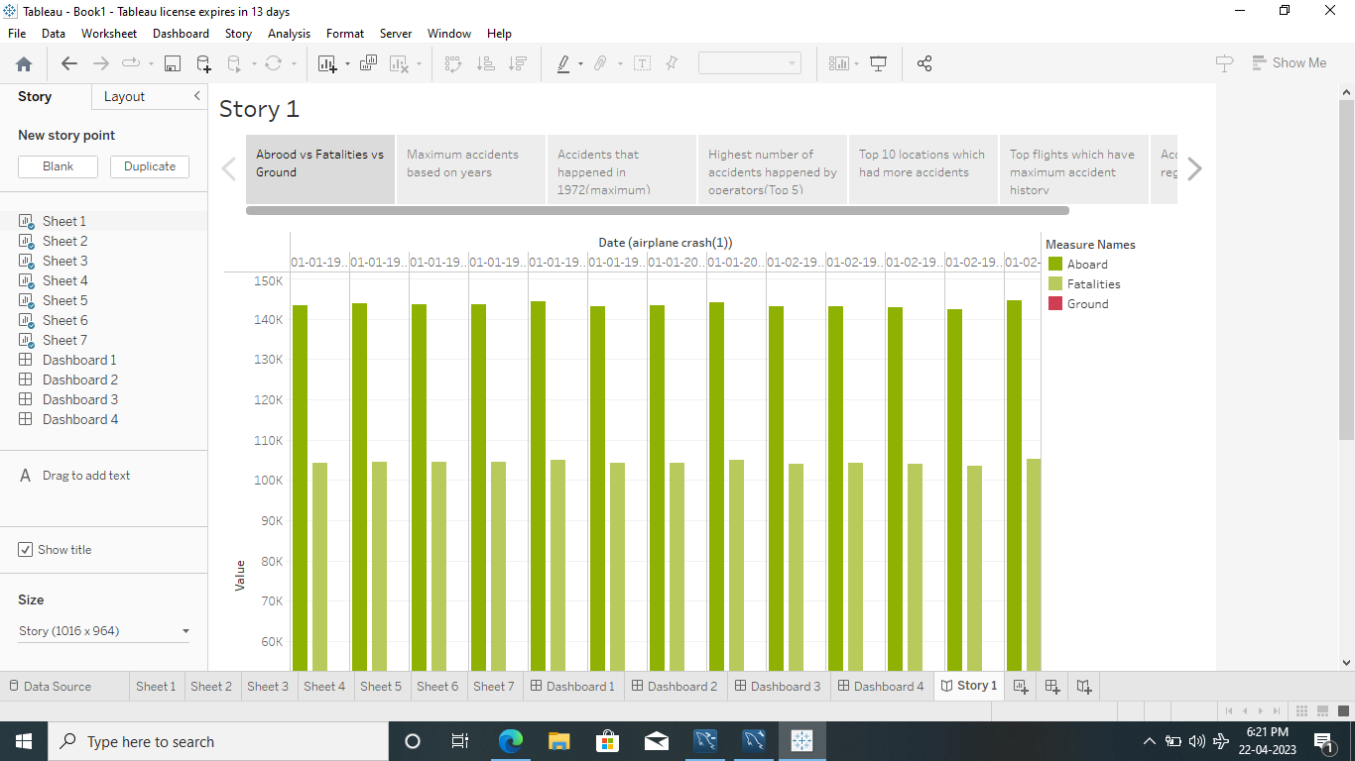

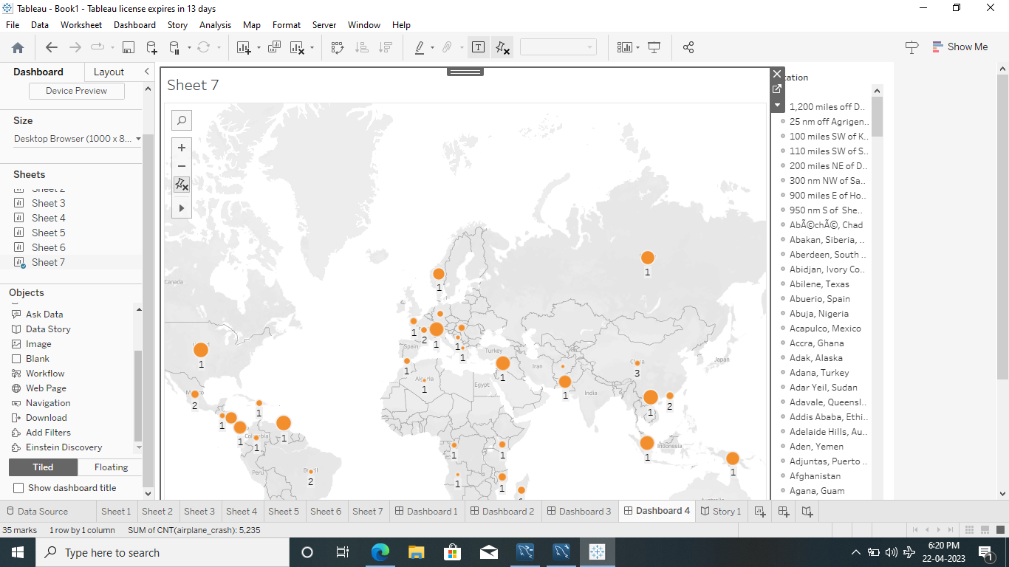

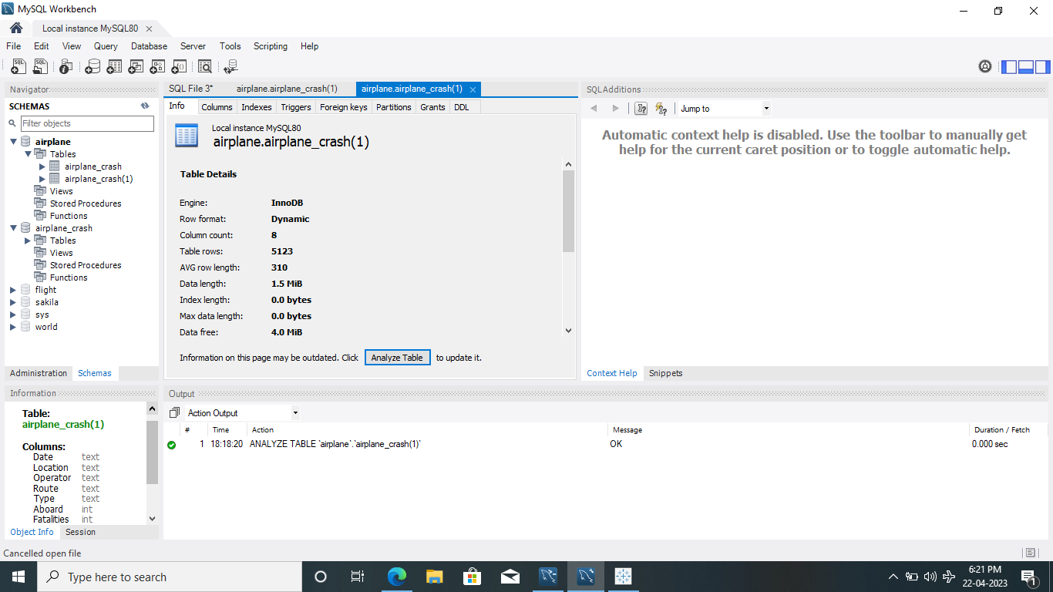

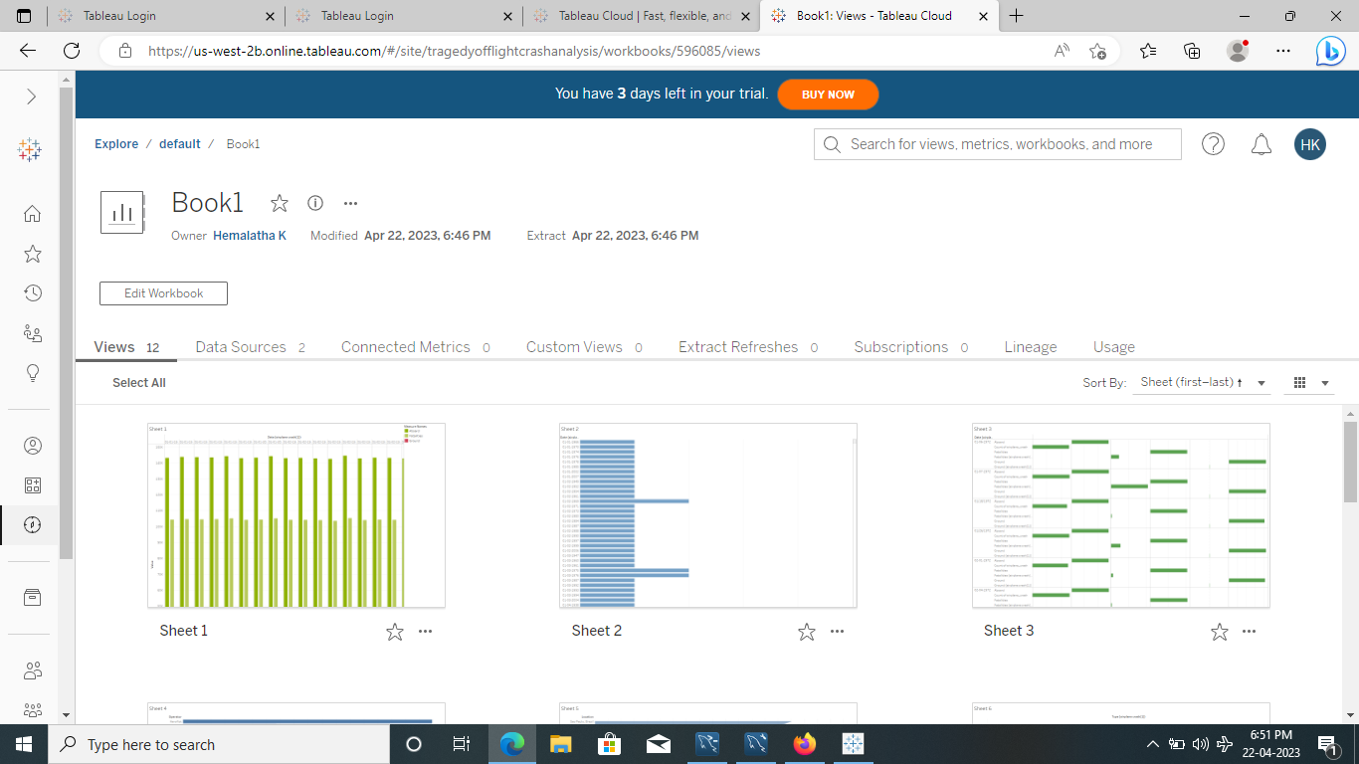

4.Advantages and Disadvantages

* To effectively discover the hazards that led to the accident and to prevent their recurrence in a future accident or incident. In the course of that investigation, additional hazards which increased damage and injury (inadequate crashworthy systems, system safeguards, rescue team response, etc.)
* Emissions from aviation are a significant contributor to climate change. Airplanes burn fossil fuel which not only releases CO2 emissions but also has strong warming non-CO2 effects due to nitrogen oxides, vapour trails and cloud formation triggered by the altitude at which aircraft operate.

5.Applications

* Aviation accident analysis is an important part of aviation safety research. We used long-term sequence aviation accident statistics to analyze the characteristics of historical aviation accidents and predict the future direction of aviation accidents.
* In the physical effects, air crash brings about death, disability and injuries. The effects from air crash are determined by among other things, the cause of the crash, the altitude and its speed at the time of crash.

6.Conclusion

* This project is performed to determine the cause of errors once an accident has happened. In the modern aviation industry, it is also used to analyze a database of past accidents in order to prevent an accident from happening. Many models have been used not only for the accident investigation but also for educational purpose
* The year and the fatalities of airplane crash analysis is given below.

7.Future scope

* Aviation accident analysis is an important part of aviation safety research. We used long-term sequence aviation accident statistics to analyze the characteristics of historical aviation accidents and predict the future direction of aviation accidents.
* Major airlines experienced no onboard fatalities and had a fatal accident rate of 0.0 per 100,000 flight hours in 2021. This contrasts sharply with general aviation, which experienced 341 on board fatalities and had a fatal accident rate of 0.951 per 100,000 flight hours.
* ssss

8.Appendix

A.Source code

<!DOCTYPE html>

<html lang="en">

<head>

<meta charset="utf-8">

<meta content="width=device-width, initial-scale=1.0" name="viewport">

<title>The Tragedy of flight :A comprehensive crash analysis</title>

<meta content="" name="description">

<meta content="" name="keywords">

<!-- Favicons -->

<link href="assets/img/favicon.png" rel="icon">

<link href="assets/img/apple-touch-icon.png" rel="apple-touch-icon">

<!-- Google Fonts -->

<link href="https://fonts.googleapis.com/css?family=Open+Sans:300,300i,400,400i,600,600i,700,700i|Raleway:300,300i,400,400i,500,500i,600,600i,700,700i|Poppins:300,300i,400,400i,500,500i,600,600i,700,700i" rel="stylesheet">

<!-- Vendor CSS Files -->

<link href="assets/vendor/aos/aos.css" rel="stylesheet">

<link href="assets/vendor/bootstrap/css/bootstrap.min.css" rel="stylesheet">

<link href="assets/vendor/bootstrap-icons/bootstrap-icons.css" rel="stylesheet">

<link href="assets/vendor/boxicons/css/boxicons.min.css" rel="stylesheet">

<link href="assets/vendor/glightbox/css/glightbox.min.css" rel="stylesheet">

<link href="assets/vendor/swiper/swiper-bundle.min.css" rel="stylesheet">

<!-- Template Main CSS File -->

<link href="assets/css/style.css" rel="stylesheet">

<!-- =======================================================

\* Template Name: The Tagedy of flight :A comprehensive crash analysis

\* Updated: Mar 10 2023 with Bootstrap v5.2.3

\* Template URL: https://bootstrapmade.com/The Tragedy of flight:A comprehensive crash analysis-multipurpose-html-template-for-free/

\* Author: BootstrapMade.com

\* License: https://bootstrapmade.com/license/

======================================================== -->

</head>

<body>

<!-- ======= Top Bar ======= -->

<section id="topbar" class="d-flex align-items-center">

<div class="container d-flex justify-content-center justify-content-md-between">

<div class="contact-info d-flex align-items-center">

<i class="bi bi-envelope-fill"></i><a href="mailto:contact@example.com">hemakanagu1806@gmail.com</a>

<i class="bi bi-phone-fill phone-icon"></i> +91 9597711406

</div>

<div class="social-links d-none d-md-block">

<a href="#" class="twitter"><i class="bi bi-twitter"></i></a>

<a href="#" class="facebook"><i class="bi bi-facebook"></i></a>

<a href="#" class="instagram"><i class="bi bi-instagram"></i></a>

<a href="#" class="linkedin"><i class="bi bi-linkedin"></i></i></a>

</div>

</div>

</section>

<!-- ======= Header ======= -->

<header id="header" class="d-flex align-items-center">

<div class="container d-flex align-items-center justify-content-between">

<h1 class="logo"><a href="index.html">The Tragedy of flight:A comprehensive crash analysis</a></h1>

<!-- Uncomment below if you prefer to use an image logo -->

<!-- <a href="index.html" class="logo"><img src="assets/img/logo.png" alt="" class="img-fluid"></a>-->

<nav id="navbar" class="navbar">

<ul>

<li><a class="nav-link scrollto active" href="#hero">Home</a></li>

<li><a class="nav-link scrollto" href="#about">About</a></li>

<li><a class="nav-link scrollto" href="#services">Services</a></li>

<li><a class="nav-link scrollto " href="#portfolio">Portfolio</a></li>

<li><a class="nav-link scrollto" href="#pricing">Pricing</a></li>

<li><a class="nav-link scrollto" href="#team">Team</a></li>

<li class="dropdown"><a href="#"><span>Drop Down</span> <i class="bi bi-chevron-down"></i></a>

<ul>

<li><a href="#">Drop Down 1</a></li>

<li class="dropdown"><a href="#"><span>Deep Drop Down</span> <i class="bi bi-chevron-right"></i></a>

<ul>

<li><a href="#">Deep Drop Down 1</a></li>

<li><a href="#">Deep Drop Down 2</a></li>

<li><a href="#">Deep Drop Down 3</a></li>

<li><a href="#">Deep Drop Down 4</a></li>

<li><a href="#">Deep Drop Down 5</a></li>

</ul>

</li>

<li><a href="#">Drop Down 2</a></li>

<li><a href="#">Drop Down 3</a></li>

<li><a href="#">Drop Down 4</a></li>

</ul>

</li>

<li><a class="nav-link scrollto" href="#contact">Contact</a></li>

</ul>

<i class="bi bi-list mobile-nav-toggle"></i>

</nav><!-- .navbar -->

</div>

</header><!-- End Header -->

<!-- ======= Hero Section ======= -->

<section id="hero" class="d-flex align-items-center">

<div class="container position-relative" data-aos="fade-up" data-aos-delay="500">

<h1>Welcome to The Tragedy of flight:A comprehensive crash analysis</h1>

<h2>We are team of talented designers making websites with Bootstrap</h2>

<a href="#about" class="btn-get-started scrollto">Get Started</a>

</div>

</section><!-- End Hero -->

<main id="main">

<!-- ======= About Section ======= -->

<section id="about" class="about">

<div class="container">

<div class="row">

<div class="col-lg-6 order-1 order-lg-2" data-aos="fade-left">

<img src="assets/img/about.jpg" class="img-fluid" alt="">

</div>

<div class="col-lg-6 pt-4 pt-lg-0 order-2 order-lg-1 content" data-aos="fade-right">

<h3>Voluptatem dignissimos provident quasi corporis voluptates sit assumenda.</h3>

<p class="fst-italic">

Lorem ipsum dolor sit amet, consectetur adipiscing elit, sed do eiusmod tempor incididunt ut labore et dolore

magna aliqua.

</p>

<ul>

<li><i class="bi bi-check-circle"></i> Ullamco laboris nisi ut aliquip ex ea commodo consequat.</li>

<li><i class="bi bi-check-circle"></i> Duis aute irure dolor in reprehenderit in voluptate velit.</li>

<li><i class="bi bi-check-circle"></i> Ullamco laboris nisi ut aliquip ex ea commodo consequat. Duis aute irure dolor in reprehenderit in voluptate trideta storacalaperda mastiro dolore eu fugiat nulla pariatur.</li>

</ul>

<p>

Ullamco laboris nisi ut aliquip ex ea commodo consequat. Duis aute irure dolor in reprehenderit in voluptate

velit esse cillum dolore eu fugiat nulla pariatur. Excepteur sint occaecat cupidatat non proident, sunt in

culpa qui officia deserunt mollit anim id est laborum

</p>

</div>

</div>

</div>

</section><!-- End About Section -->

<!-- ======= Why Us Section ======= -->

<section id="why-us" class="why-us">

<div class="container">

<div class="row">

<div class="col-lg-4" data-aos="fade-up">

<div class="box">

<span>01</span>

<h4>Lorem Ipsum</h4>

<p>Ulamco laboris nisi ut aliquip ex ea commodo consequat. Et consectetur ducimus vero placeat</p>

</div>

</div>

<div class="col-lg-4 mt-4 mt-lg-0" data-aos="fade-up" data-aos-delay="150">

<div class="box">

<span>02</span>

<h4>Repellat Nihil</h4>

<p>Dolorem est fugiat occaecati voluptate velit esse. Dicta veritatis dolor quod et vel dire leno para dest</p>

</div>

</div>

<div class="col-lg-4 mt-4 mt-lg-0" data-aos="fade-up" data-aos-delay="300">

<div class="box">

<span>03</span>

<h4> Ad ad velit qui</h4>

<p>Molestiae officiis omnis illo asperiores. Aut doloribus vitae sunt debitis quo vel nam quis</p>

</div>

</div>

</div>

</div>

</section><!-- End Why Us Section -->

<!-- ======= Clients Section ======= -->

<section id="clients" class="clients">

<div class="container" data-aos="zoom-in">

<div class="row d-flex align-items-center">

<div class="col-lg-2 col-md-4 col-6">

<img src="assets/img/clients/client-1.png" class="img-fluid" alt="">

</div>

<div class="col-lg-2 col-md-4 col-6">

<img src="assets/img/clients/client-2.png" class="img-fluid" alt="">

</div>

<div class="col-lg-2 col-md-4 col-6">

<img src="assets/img/clients/client-3.png" class="img-fluid" alt="">

</div>

<div class="col-lg-2 col-md-4 col-6">

<img src="assets/img/clients/client-4.png" class="img-fluid" alt="">

</div>

<div class="col-lg-2 col-md-4 col-6">

<img src="assets/img/clients/client-5.png" class="img-fluid" alt="">

</div>

<div class="col-lg-2 col-md-4 col-6">

<img src="assets/img/clients/client-6.png" class="img-fluid" alt="">

</div>

</div>

</div>

</section><!-- End Clients Section -->

<!-- ======= Services Section ======= -->

<section id="services" class="services">

<div class="container">

<div class="section-title">

<span>Services</span>

<h2>Services</h2>

<p>Sit sint consectetur velit quisquam cupiditate impedit suscipit alias</p>

</div>

<div class="row">

<div class="col-lg-4 col-md-6 d-flex align-items-stretch" data-aos="fade-up">

<div class="icon-box">

<div class="icon"><i class="bx bxl-dribbble"></i></div>

<h4><a href="">Lorem Ipsum</a></h4>

<p>Voluptatum deleniti atque corrupti quos dolores et quas molestias excepturi</p>

</div>

</div>

<div class="col-lg-4 col-md-6 d-flex align-items-stretch mt-4 mt-md-0" data-aos="fade-up" data-aos-delay="150">

<div class="icon-box">

<div class="icon"><i class="bx bx-file"></i></div>

<h4><a href="">Sed ut perspiciatis</a></h4>

<p>Duis aute irure dolor in reprehenderit in voluptate velit esse cillum dolore</p>

</div>

</div>

<div class="col-lg-4 col-md-6 d-flex align-items-stretch mt-4 mt-lg-0" data-aos="fade-up" data-aos-delay="300">

<div class="icon-box">

<div class="icon"><i class="bx bx-tachometer"></i></div>

<h4><a href="">Magni Dolores</a></h4>

<p>Excepteur sint occaecat cupidatat non proident, sunt in culpa qui officia</p>

</div>

</div>

<div class="col-lg-4 col-md-6 d-flex align-items-stretch mt-4" data-aos="fade-up" data-aos-delay="450">

<div class="icon-box">

<div class="icon"><i class="bx bx-world"></i></div>

<h4><a href="">Nemo Enim</a></h4>

<p>At vero eos et accusamus et iusto odio dignissimos ducimus qui blanditiis</p>

</div>

</div>

<div class="col-lg-4 col-md-6 d-flex align-items-stretch mt-4" data-aos="fade-up" data-aos-delay="600">

<div class="icon-box">

<div class="icon"><i class="bx bx-slideshow"></i></div>

<h4><a href="">Dele cardo</a></h4>

<p>Quis consequatur saepe eligendi voluptatem consequatur dolor consequuntur</p>

</div>

</div>

<div class="col-lg-4 col-md-6 d-flex align-items-stretch mt-4" data-aos="fade-up" data-aos-delay="750">

<div class="icon-box">

<div class="icon"><i class="bx bx-arch"></i></div>

<h4><a href="">Divera don</a></h4>

<p>Modi nostrum vel laborum. Porro fugit error sit minus sapiente sit aspernatur</p>

</div>

</div>

</div>

</div>

</section><!-- End Services Section -->

<!-- ======= Cta Section ======= -->

<section id="cta" class="cta">

<div class="container" data-aos="zoom-in">

<div class="text-center">

<h3>Call To Action</h3>

<p> Duis aute irure dolor in reprehenderit in voluptate velit esse cillum dolore eu fugiat nulla pariatur. Excepteur sint occaecat cupidatat non proident, sunt in culpa qui officia deserunt mollit anim id est laborum.</p>

<a class="cta-btn" href="#">Call To Action</a>

</div>

</div>

</section><!-- End Cta Section -->

<!-- ======= Portfolio Section ======= -->

<section id="portfolio" class="portfolio">

<div class="container">

<div class="section-title">

<span>Portfolio</span>

<h2>Portfolio</h2>

<p>Sit sint consectetur velit quisquam cupiditate impedit suscipit alias</p>

</div>

<div class="row" data-aos="fade-up">

<div class="col-lg-12 d-flex justify-content-center">

<ul id="portfolio-flters">

<li data-filter="\*" class="filter-active">All</li>

<li data-filter=".filter-app">App</li>

<li data-filter=".filter-card">Card</li>

<li data-filter=".filter-web">Web</li>

</ul>

</div>

</div>

<div class="row portfolio-container" data-aos="fade-up" data-aos-delay="150">

<div class="col-lg-4 col-md-6 portfolio-item filter-app">

<img src="assets/img/portfolio/portfolio-1.jpg" class="img-fluid" alt="">

<div class="portfolio-info">

<h4>App 1</h4>

<p>App</p>

<a href="assets/img/portfolio/portfolio-1.jpg" data-gallery="portfolioGallery" class="portfolio-lightbox preview-link" title="App 1"><i class="bx bx-plus"></i></a>

<a href="portfolio-details.html" class="details-link" title="More Details"><i class="bx bx-link"></i></a>

</div>

</div>

<div class="col-lg-4 col-md-6 portfolio-item filter-web">

<img src="assets/img/portfolio/portfolio-2.jpg" class="img-fluid" alt="">

<div class="portfolio-info">

<h4>Web 3</h4>

<p>Web</p>

<a href="assets/img/portfolio/portfolio-2.jpg" data-gallery="portfolioGallery" class="portfolio-lightbox preview-link" title="Web 3"><i class="bx bx-plus"></i></a>

<a href="portfolio-details.html" class="details-link" title="More Details"><i class="bx bx-link"></i></a>

</div>

</div>

<div class="col-lg-4 col-md-6 portfolio-item filter-app">

<img src="assets/img/portfolio/portfolio-3.jpg" class="img-fluid" alt="">

<div class="portfolio-info">

<h4>App 2</h4>

<p>App</p>

<a href="assets/img/portfolio/portfolio-3.jpg" data-gallery="portfolioGallery" class="portfolio-lightbox preview-link" title="App 2"><i class="bx bx-plus"></i></a>

<a href="portfolio-details.html" class="details-link" title="More Details"><i class="bx bx-link"></i></a>

</div>

</div>

<div class="col-lg-4 col-md-6 portfolio-item filter-card">

<img src="assets/img/portfolio/portfolio-4.jpg" class="img-fluid" alt="">

<div class="portfolio-info">

<h4>Card 2</h4>

<p>Card</p>

<a href="assets/img/portfolio/portfolio-4.jpg" data-gallery="portfolioGallery" class="portfolio-lightbox preview-link" title="Card 2"><i class="bx bx-plus"></i></a>

<a href="portfolio-details.html" class="details-link" title="More Details"><i class="bx bx-link"></i></a>

</div>

</div>

<div class="col-lg-4 col-md-6 portfolio-item filter-web">

<img src="assets/img/portfolio/portfolio-5.jpg" class="img-fluid" alt="">

<div class="portfolio-info">

<h4>Web 2</h4>

<p>Web</p>

<a href="assets/img/portfolio/portfolio-5.jpg" data-gallery="portfolioGallery" class="portfolio-lightbox preview-link" title="Web 2"><i class="bx bx-plus"></i></a>

<a href="portfolio-details.html" class="details-link" title="More Details"><i class="bx bx-link"></i></a>

</div>

</div>

<div class="col-lg-4 col-md-6 portfolio-item filter-app">

<img src="assets/img/portfolio/portfolio-6.jpg" class="img-fluid" alt="">

<div class="portfolio-info">

<h4>App 3</h4>

<p>App</p>

<a href="assets/img/portfolio/portfolio-6.jpg" data-gallery="portfolioGallery" class="portfolio-lightbox preview-link" title="App 3"><i class="bx bx-plus"></i></a>

<a href="portfolio-details.html" class="details-link" title="More Details"><i class="bx bx-link"></i></a>

</div>

</div>

<div class="col-lg-4 col-md-6 portfolio-item filter-card">

<img src="assets/img/portfolio/portfolio-7.jpg" class="img-fluid" alt="">

<div class="portfolio-info">

<h4>Card 1</h4>

<p>Card</p>

<a href="assets/img/portfolio/portfolio-7.jpg" data-gallery="portfolioGallery" class="portfolio-lightbox preview-link" title="Card 1"><i class="bx bx-plus"></i></a>

<a href="portfolio-details.html" class="details-link" title="More Details"><i class="bx bx-link"></i></a>

</div>

</div>

<div class="col-lg-4 col-md-6 portfolio-item filter-card">

<img src="assets/img/portfolio/portfolio-8.jpg" class="img-fluid" alt="">

<div class="portfolio-info">

<h4>Card 3</h4>

<p>Card</p>

<a href="assets/img/portfolio/portfolio-8.jpg" data-gallery="portfolioGallery" class="portfolio-lightbox preview-link" title="Card 3"><i class="bx bx-plus"></i></a>

<a href="portfolio-details.html" class="details-link" title="More Details"><i class="bx bx-link"></i></a>

</div>

</div>

<div class="col-lg-4 col-md-6 portfolio-item filter-web">

<img src="assets/img/portfolio/portfolio-9.jpg" class="img-fluid" alt="">

<div class="portfolio-info">

<h4>Web 3</h4>

<p>Web</p>

<a href="assets/img/portfolio/portfolio-9.jpg" data-gallery="portfolioGallery" class="portfolio-lightbox preview-link" title="Web 3"><i class="bx bx-plus"></i></a>

<a href="portfolio-details.html" class="details-link" title="More Details"><i class="bx bx-link"></i></a>

</div>

</div>

</div>

</div>

</section><!-- End Portfolio Section -->

<!-- ======= Pricing Section ======= -->

<section id="pricing" class="pricing">

<div class="container">

<div class="section-title">

<span>Pricing</span>

<h2>Pricing</h2>

<p>Sit sint consectetur velit quisquam cupiditate impedit suscipit alias</p>

</div>

<div class="row">

<div class="col-lg-4 col-md-6" data-aos="zoom-in" data-aos-delay="150">

<div class="box">

<h3>Free</h3>

<h4><sup>$</sup>0<span> / month</span></h4>

<ul>

<li>Aida dere</li>

<li>Nec feugiat nisl</li>

<li>Nulla at volutpat dola</li>

<li class="na">Pharetra massa</li>

<li class="na">Massa ultricies mi</li>

</ul>

<div class="btn-wrap">

<a href="#" class="btn-buy">Buy Now</a>

</div>

</div>

</div>

<div class="col-lg-4 col-md-6 mt-4 mt-md-0" data-aos="zoom-in">

<div class="box featured">

<h3>Business</h3>

<h4><sup>$</sup>19<span> / month</span></h4>

<ul>

<li>Aida dere</li>

<li>Nec feugiat nisl</li>

<li>Nulla at volutpat dola</li>

<li>Pharetra massa</li>

<li class="na">Massa ultricies mi</li>

</ul>

<div class="btn-wrap">

<a href="#" class="btn-buy">Buy Now</a>

</div>

</div>

</div>

<div class="col-lg-4 col-md-6 mt-4 mt-lg-0" data-aos="zoom-in" data-aos-delay="150">

<div class="box">

<h3>Developer</h3>

<h4><sup>$</sup>29<span> / month</span></h4>

<ul>

<li>Aida dere</li>

<li>Nec feugiat nisl</li>

<li>Nulla at volutpat dola</li>

<li>Pharetra massa</li>

<li>Massa ultricies mi</li>

</ul>

<div class="btn-wrap">

<a href="#" class="btn-buy">Buy Now</a>

</div>

</div>

</div>

</div>

</div>

</section><!-- End Pricing Section -->

<!-- ======= Team Section ======= -->

<section id="team" class="team">

<div class="container">

<div class="section-title">

<span>Team</span>

<h2>Team</h2>

<p>Sit sint consectetur velit quisquam cupiditate impedit suscipit alias</p>

</div>

<div class="row">

<div class="col-lg-4 col-md-6 d-flex align-items-stretch" data-aos="zoom-in">

<div class="member">

<img src="assets/img/team/team-1.jpg" alt="">

<h4>Walter White</h4>

<span>Chief Executive Officer</span>

<p>

Magni qui quod omnis unde et eos fuga et exercitationem. Odio veritatis perspiciatis quaerat qui aut aut aut

</p>

<div class="social">

<a href=""><i class="bi bi-twitter"></i></a>

<a href=""><i class="bi bi-facebook"></i></a>

<a href=""><i class="bi bi-instagram"></i></a>

<a href=""><i class="bi bi-linkedin"></i></a>

</div>

</div>

</div>

<div class="col-lg-4 col-md-6 d-flex align-items-stretch" data-aos="zoom-in">

<div class="member">

<img src="assets/img/team/team-2.jpg" alt="">

<h4>Sarah Jhinson</h4>

<span>Product Manager</span>

<p>

Repellat fugiat adipisci nemo illum nesciunt voluptas repellendus. In architecto rerum rerum temporibus

</p>

<div class="social">

<a href=""><i class="bi bi-twitter"></i></a>

<a href=""><i class="bi bi-facebook"></i></a>

<a href=""><i class="bi bi-instagram"></i></a>

<a href=""><i class="bi bi-linkedin"></i></a>

</div>

</div>

</div>

<div class="col-lg-4 col-md-6 d-flex align-items-stretch" data-aos="zoom-in">

<div class="member">

<img src="assets/img/team/team-3.jpg" alt="">

<h4>William Anderson</h4>

<span>CTO</span>

<p>

Voluptas necessitatibus occaecati quia. Earum totam consequuntur qui porro et laborum toro des clara

</p>

<div class="social">

<a href=""><i class="bi bi-twitter"></i></a>

<a href=""><i class="bi bi-facebook"></i></a>

<a href=""><i class="bi bi-instagram"></i></a>

<a href=""><i class="bi bi-linkedin"></i></a>

</div>

</div>

</div>

</div>

</div>

</section><!-- End Team Section -->

<!-- ======= Contact Section ======= -->

<section id="contact" class="contact">

<div class="container">

<div class="section-title">

<span>Contact</span>

<h2>Contact</h2>

<p>Sit sint consectetur velit quisquam cupiditate impedit suscipit alias</p>

</div>

<div class="row" data-aos="fade-up">

<div class="col-lg-6">

<div class="info-box mb-4">

<i class="bx bx-map"></i>

<h3>Our Address</h3>

<p>A108 Adam Street, New York, NY 535022</p>

</div>

</div>

<div class="col-lg-3 col-md-6">

<div class="info-box mb-4">

<i class="bx bx-envelope"></i>

<h3>Email Us</h3>

<p>contact@example.com</p>

</div>

</div>

<div class="col-lg-3 col-md-6">

<div class="info-box mb-4">

<i class="bx bx-phone-call"></i>

<h3>Call Us</h3>

<p>+1 5589 55488 55</p>

</div>

</div>

</div>

<div class="row" data-aos="fade-up">

<div class="col-lg-6 ">

<iframe class="mb-4 mb-lg-0" src="https://www.google.com/maps/embed?pb=!1m14!1m8!1m3!1d12097.433213460943!2d-74.0062269!3d40.7101282!3m2!1i1024!2i768!4f13.1!3m3!1m2!1s0x0%3A0xb89d1fe6bc499443!2sDowntown+Conference+Center!5e0!3m2!1smk!2sbg!4v1539943755621" frameborder="0" style="border:0; width: 100%; height: 384px;" allowfullscreen></iframe>

</div>

<div class="col-lg-6">

<form action="forms/contact.php" method="post" role="form" class="php-email-form">

<div class="row">

<div class="col-md-6 form-group">

<input type="text" name="name" class="form-control" id="name" placeholder="Your Name" required>

</div>

<div class="col-md-6 form-group mt-3 mt-md-0">

<input type="email" class="form-control" name="email" id="email" placeholder="Your Email" required>

</div>

</div>

<div class="form-group mt-3">

<input type="text" class="form-control" name="subject" id="subject" placeholder="Subject" required>

</div>

<div class="form-group mt-3">

<textarea class="form-control" name="message" rows="5" placeholder="Message" required></textarea>

</div>

<div class="my-3">

<div class="loading">Loading</div>

<div class="error-message"></div>

<div class="sent-message">Your message has been sent. Thank you!</div>

</div>

<div class="text-center"><button type="submit">Send Message</button></div>

</form>

</div>

</div>

</div>

</section><!-- End Contact Section -->

</main><!-- End #main -->

<!-- ======= Footer ======= -->

<footer id="footer">

<div class="footer-top">

<div class="container">

<div class="row">

<div class="col-lg-4 col-md-6">

<div class="footer-info">

<h3>The Tragedy of flight:A comprehensive crash analysis</h3>

<p>

A108 Adam Street <br>

NY 535022, USA<br><br>

<strong>Phone:</strong> +91 9597711406<br>

<strong>Email:</strong> hemakanagu1806@gmail.com<br>

</p>

<div class="social-links mt-3">

<a href="#" class="twitter"><i class="bx bxl-twitter"></i></a>

<a href="#" class="facebook"><i class="bx bxl-facebook"></i></a>

<a href="#" class="instagram"><i class="bx bxl-instagram"></i></a>

<a href="#" class="google-plus"><i class="bx bxl-skype"></i></a>

<a href="#" class="linkedin"><i class="bx bxl-linkedin"></i></a>

</div>

</div>

</div>

<div class="col-lg-2 col-md-6 footer-links">

<h4>Useful Links</h4>

<ul>

<li><i class="bx bx-chevron-right"></i> <a href="#">Home</a></li>

<li><i class="bx bx-chevron-right"></i> <a href="#">About us</a></li>

<li><i class="bx bx-chevron-right"></i> <a href="#">Services</a></li>

<li><i class="bx bx-chevron-right"></i> <a href="#">Terms of service</a></li>

<li><i class="bx bx-chevron-right"></i> <a href="#">Privacy policy</a></li>

</ul>

</div>

<div class="col-lg-2 col-md-6 footer-links">

<h4>Our Services</h4>

<ul>

<li><i class="bx bx-chevron-right"></i> <a href="#">Web Design</a></li>

<li><i class="bx bx-chevron-right"></i> <a href="#">Web Development</a></li>

<li><i class="bx bx-chevron-right"></i> <a href="#">Product Management</a></li>

<li><i class="bx bx-chevron-right"></i> <a href="#">Marketing</a></li>

<li><i class="bx bx-chevron-right"></i> <a href="#">Graphic Design</a></li>

</ul>

</div>

<div class="col-lg-4 col-md-6 footer-newsletter">

<h4>Our Newsletter</h4>

<p>Tamen quem nulla quae legam multos aute sint culpa legam noster magna</p>

<form action="" method="post">

<input type="email" name="email"><input type="submit" value="Subscribe">

</form>

</div>

</div>

</div>

</div>

<div class="container">

<div class="copyright">

&copy; Copyright <strong><span>The Tragedy of flight:A comprehensive crash analysis</span></strong>. All Rights Reserved

</div>

<div class="credits">

<!-- All the links in the footer should remain intact. -->

<!-- You can delete the links only if you purchased the pro version. -->

<!-- Licensing information: https://bootstrapmade.com/license/ -->

<!-- Purchase the pro version with working PHP/AJAX contact form: https://bootstrapmade.com/The Tragedy of flight:A comprehensive crash analysis-multipurpose-html-template-for-free/ -->

Designed by <a href="https://bootstrapmade.com/">BootstrapMade</a>

</div>

</div>

</footer><!-- End Footer -->

<a href="#" class="back-to-top d-flex align-items-center justify-content-center"><i class="bi bi-arrow-up-short"></i></a>

<div id="preloader"></div>

<!-- Vendor JS Files -->

<script src="assets/vendor/aos/aos.js"></script>

<script src="assets/vendor/bootstrap/js/bootstrap.bundle.min.js"></script>

<script src="assets/vendor/glightbox/js/glightbox.min.js"></script>

<script src="assets/vendor/isotope-layout/isotope.pkgd.min.js"></script>

<script src="assets/vendor/swiper/swiper-bundle.min.js"></script>

<script src="assets/vendor/php-email-form/validate.js"></script>

<!-- Template Main JS File -->

<script src="assets/js/main.js"></script>

</body>

</html>